**Price Elasticity of Demand**

**1. Definition** Price Elasticity of Demand (PED) measures how the quantity demanded of a good responds to a change in its price.

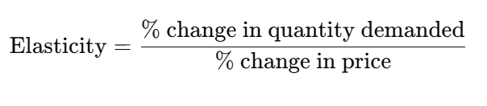

**2. Interpretation of Elasticity Values**

|  |  |  |
| --- | --- | --- |
| **Elasticity (E)** | **Demand Type** | **Interpretation** |
| E > 1 | Elastic | Quantity demanded is highly responsive to price |
| E = 1 | Unit Elastic | Proportional change in quantity and price |
| E < 1 | Inelastic | Quantity demanded is less responsive to price |
| E = 0 | Perfectly Inelastic | No response to price change |
| E = ∞ | Perfectly Elastic | Infinite response to a small price change |

**3. Formulae**

* **Log-Log Regression Coefficient Interpretation:**

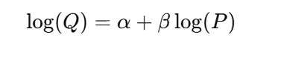

**4. Factors Influencing Elasticity**

* Availability of substitutes
* Necessity vs. luxury
* Time period
* Proportion of income spent on the good

**5. Use Cases in Business**

* Pricing Strategy: Determine if raising prices will increase or decrease revenue.
* Revenue Forecasting: Simulate impact of pricing changes on volume and revenue.
* Demand Simulation: Estimate expected demand at different price points.
* Discount Optimization: Combine elasticity with marginal cost to find optimal discount levels.

**6. Advanced Concepts**

* Cross-Price Elasticity: Impact of price change of one good on the demand of another.
* Income Elasticity: How demand changes with consumer income.
* Elasticity by Segment: Elasticity can vary by geography, product category, or customer group.

**7. Is Elasticity Negative?** Yes, **price elasticity of demand is typically negative** due to the **law of demand**:

When price increases, quantity demanded decreases (and vice versa).

Example:

* Price ↑ 10%, Quantity ↓ 20% → Elasticity = -2.0

However, in business and economic practice, the **absolute value** is often used to classify elasticity:

* Elasticity of -2.0 → often reported as 2.0 (Elastic)
* Elasticity of -0.5 → reported as 0.5 (Inelastic)

**8. Reference Links**

* [Investopedia - Price Elasticity of Demand](https://www.investopedia.com/terms/p/priceelasticity.asp?utm_source=chatgpt.com)
* [Khan Academy - Elasticity Overview](https://www.khanacademy.org/economics-finance-domain/ap-microeconomics/unit-2-supply-and-demnd/23/v/introduction-to-price-elasticity-of-demand-ap-microeconomics-khan-academy?utm_source=chatgpt.com)
* [OpenStax - Price Elasticity of Demand](https://openstax.org/books/principles-economics-3e/pages/5-1-price-elasticity-of-demand-and-price-elasticity-of-supply?utm_source=chatgpt.com)